ENG200010 Engineering Technology Design Project
Assignment 5
Dang Khoa Le
Student ID: 103844421
Major: Bachelor of Software Engineering

Abstract— This document presenting the demonstration of the Assignment 5, Create a VI for a design of two-way traffic light system using the NI-DAQ system.
I. System layers:
The VI design consist of a Queue Operation - system (using Obtain Queue, Enqueue Element, Dequeue Element, Flush Queue and Release Queue) that align each Traffic Lights’ stages, connected to a NI-DAQ interface - systems of LEDs.

1. Set Up:
The majority of the system’s components are allocated inside the While loop, which can be aborted by using the STOP button, linked directly to the loop condition.

By using the 2 DAQ Assistances in LabVIEW, the design is capable to interface with the NI-DAQ module and allows connection with the LED systems. The set of Traffic Light 1 LEDs is connected to pin 5-7 (DAQ Assistance 1) and the set of Traffic Light 2 LEDs is to pin 2-4 (DAQ Assistance 2) (in the Red-Amber-Green LED sequence respectively).
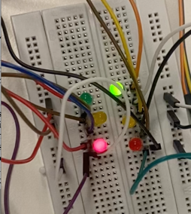
2. System Analysis:
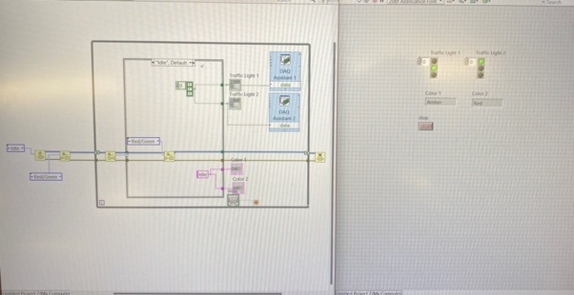
Using Obtain Queue and Enqueue Element function to initialise the default (initial) stage of the machine to be Idle, which will move to the first stage Red/Green (Traffic Light 1 display red and Traffic Light 2 display green) using Enqueue Element once the loop has been turned on. They will queue out and connect to the Shift register at the edge of the While loop to store their previous data.

I also generate multiple arrays to store T/F (Boolean) constants each case in order to send the turning on and off signal to the Traffic Lights’ LEDs.

Two set of 3x Round LEDs array and A String indicator is also implemented in the Front Panel to keep track on the current LED’s status for Traffic Light 1 and 2 (Optional).

II. Mode And Stage - Components:
There are an Enum (set to be Auto-def) to store and pair the two Traffic Lights status stages, which are Red/Green, Red/Amber, Green/Red, Amber/Red (TF1/TF2 status).

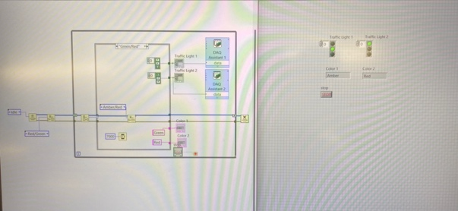
The first case appears to be Red/Green, followed by Red/Amber, Green/Red, and lastly Amber/Red before moving back to Red/Green (restart one completed loop).

All Traffic Light stages are stored in the Case structure with one case stage.
In each stage cases, there will be a Timer, an Enqueue Element to move to next stage after timer finished, and 2 arrays of 3x T/F (Boolean) constants that connected to the 2 DAQ Assistance and execute the 2 Traffic Light LED - statuses on the breadboard.

III. Timers:
The Wait (ms) function is stored within all stage cases (apart from Idle) to convert the numerical constant into the waiting time in millisecond and executed to the required processing time, in order to wait until moving to the next stages.
The Red, Amber and Green LEDs will have the waiting time of 10s, 3s and 7s by respectively, therefore, my Red/Green, Red/Amber, Green/Red, Amber/Red cases will store the waiting times of 7s, 3s, 7s, 3s, in order.

